Azure Architecture

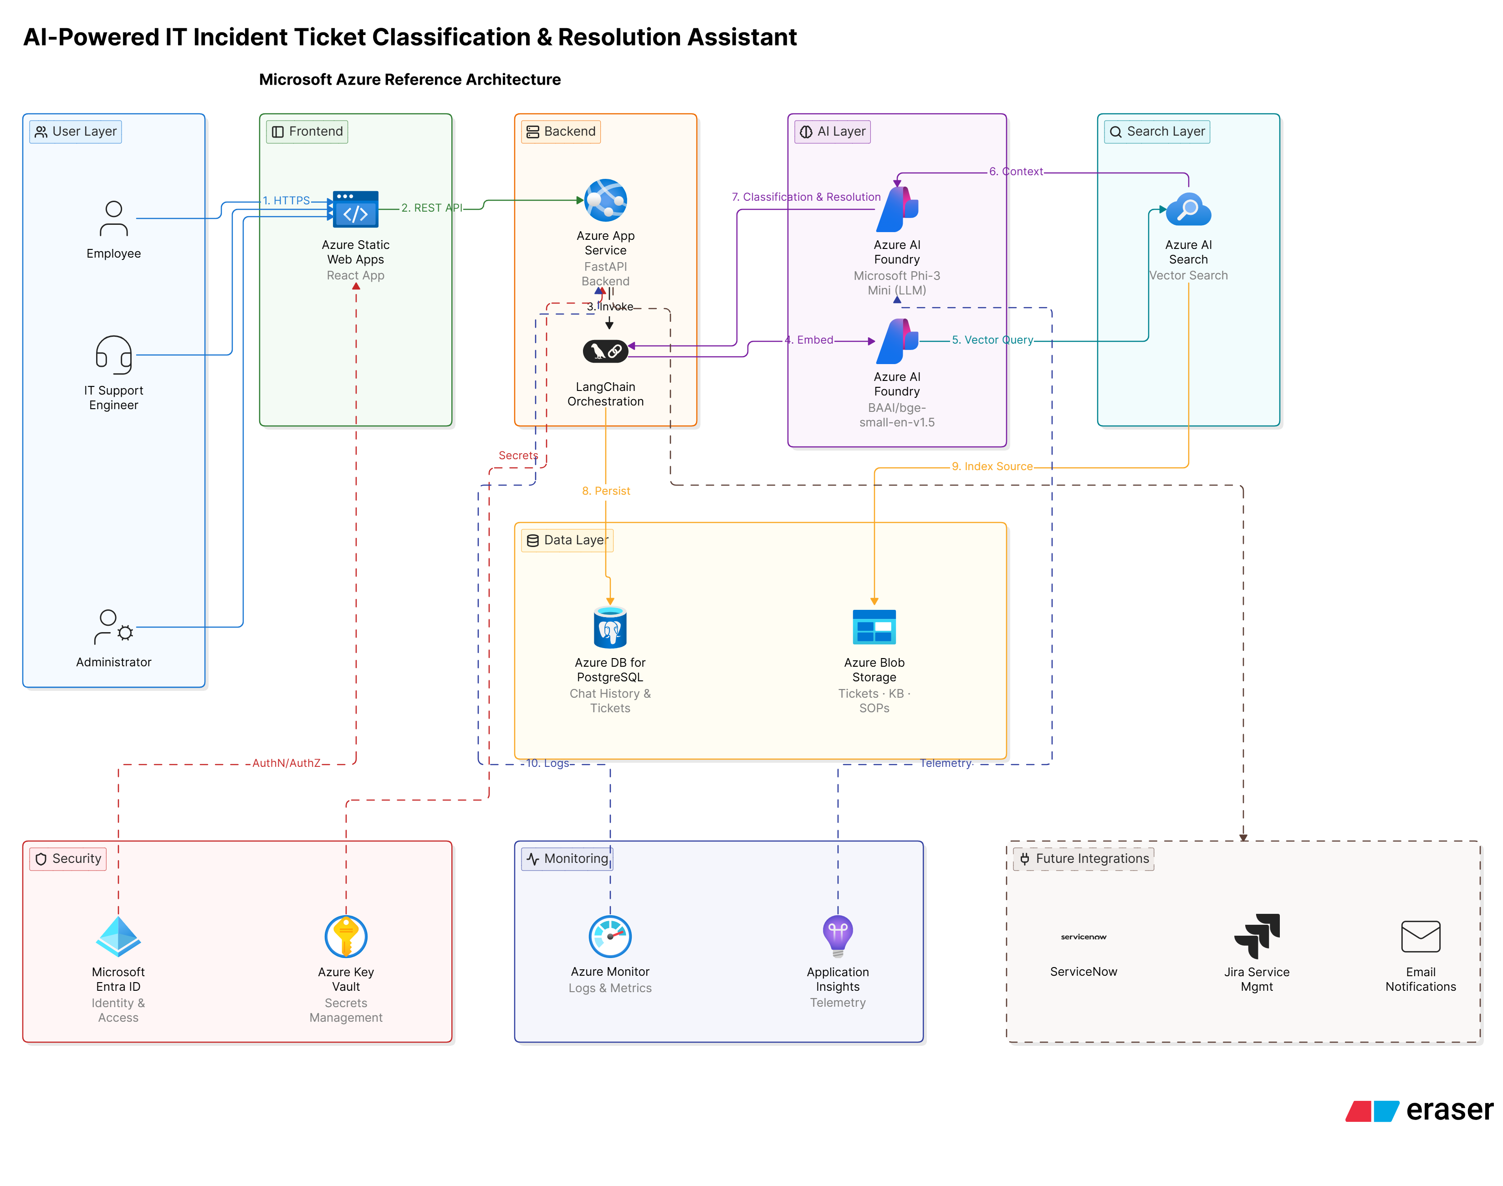
Application Component | Technology Used | Azure Service | Reason for Using Azure Service
React Frontend | React.js | Azure Static Web Apps | Hosts the React frontend with automatic deployment, HTTPS, and global availability.
Backend API | FastAPI | Azure App Service | Deploys the FastAPI backend without managing servers and supports automatic scaling.
Authentication | JWT / OAuth | Microsoft Entra ID (Azure AD) | Provides secure enterprise authentication and identity management.
API Management | REST APIs | Azure API Management | Secures, monitors, and manages backend APIs.
AI Orchestration | LangChain | Azure App Service | Runs the LangChain pipeline as part of the backend application.
Large Language Model | Microsoft Phi-3 Mini | Azure AI Foundry / Azure Machine Learning | Hosts and serves the open-source Phi-3 Mini model for inference.
Embedding Model | BAAI/bge-small-en-v1.5 | Azure AI Foundry / Azure Machine Learning | Generates embeddings for tickets and user queries.
Vector Database | FAISS | Azure AI Search (Vector Search) | Stores and retrieves vector embeddings with built-in semantic search capabilities.
Relational Database | PostgreSQL | Azure Database for PostgreSQL – Flexible Server | Managed PostgreSQL service for storing users, tickets, chat history, and logs.
Knowledge Repository | KB Articles, SOPs, Historical Tickets | Azure Blob Storage | Stores enterprise documents and historical ticket data.
Monitoring & Logging | Python Logging | Azure Monitor + Application Insights | Monitors application health, API performance, and logs.
Secrets Management | API Keys, Database Credentials | Azure Key Vault | Securely stores secrets, connection strings, and API keys.
Notifications (Future) | Email Service | Azure Communication Services | Sends email notifications to users.
CI/CD | GitHub | GitHub Actions + Azure App Service Deployment | Automates build, testing, and deployment of the application.

